Day11
SQL Joins & Subqueries

Project 1: Employee and Department Analysis

Objective: Combine employee and department data to answer business questions about staffing and salary.
1. create database mini37_db;
2. use mini37_db;
3. create table employee(emp_id int primary key,name varchar(50),dept_id int,salary decimal(10,2),foreign key(dept_id)references department(dept_id));
4.create table department(dept_id int primary key,dept_name varchar(50));

5.insert into department(dept_id,dept_name)values(1,'HR'), (2,'IT'), (3,'finance'), (4,'marketing'),(5,'logistics');
6. insert into employee(emp_id,name,dept_id,salary)values(101,'Arjun',2,45000),
(102,'Priya',1,52000), (103,'Karthick',2,40000), (104,'Divya',3,60000), (105,'sneha',4,70000);
7. select* from department;
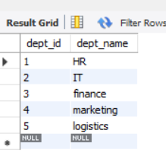
8. select * from employee;
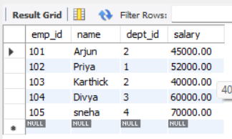
-----(Inner Join): Find the name of each employee and their corresponding department name. -----
9. select e.emp_id,e.name,d.dept_name from employee e inner join department d on e.dept_id=d.dept_id;
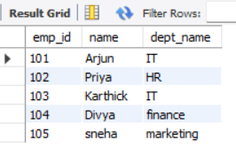

----(Left Join): Find all departments, and list the employees in them. Include departments that may not have any employees yet -----

10. select d.dept_name,e.name from department d left join employee e on d.dept_id=e.dept_id;
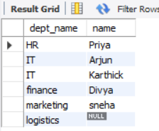

------(Join with Aggregation): Find the average salary for each department. –
11. select d.dept_name,avg(e.salary) as avg_salary from department d join employee e on d.dept_id=e.dept_id group by d.dept_name;
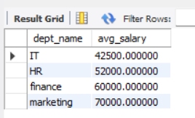

Project 2: Customer Segmentation using Subqueries
Objective: Identify customers who have placed at least one order but have not yet rated a product.
1. create database mini38_db;
2.use mini38_db;
3. create table customer(order_id int ,customer_id int primary key ,order_date date);
4.create table rating(rating_id int primary key,customer_id int,product_id int,rating decimal(10,2),foreign key(customer_id) references customer(customer_id));
5. insert into customer values(001,101,'2018-05-10'),(002,102,'2020-03-12'),(003,103,'2020-02-11'),(004,104,'2023-05-11');
6.select * from customer;
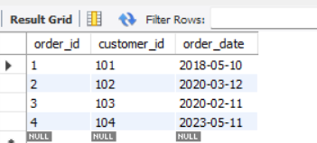
7. insert into rating values(001,101,201,4),(002,102,202,3.5),(003,103,203,3);
8.select * from rating;
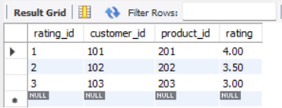

-------Find the customer_ids of customers who are in the orders table but not in the ratings table -----
9. select customer_id from customer where customer_id not in(select customer_id from rating);
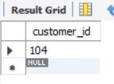
--------Alternative with a Join: You can also solve this with a LEFT JOIN.-----
10.select c.customer_id from customer c left join rating r on c.customer_id=r.customer_id where r.customer_id is null;
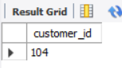

Project 3: Product-Sales Analysis

Objective: Find the total sales revenue for each product category.
1. create database mini39_db;
2.use mini39_db;
3. create table product(product_id int primary key,product_name varchar(50));
4.create table sales(customer_id int primary key,customer_name varchar(50),product_id int,sales decimal(10,2),foreign key(product_id) references product(product_id));
5. insert into product values(001,'product A'),(002,'Product B'),(003,'product C'),(004,'product D');
6.select * from product;
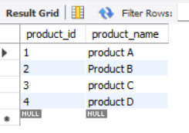
7. insert into sales values(101,'priya',001,200),(102,'Anu',001,300),(103,'Uma',002,400),(104,'Ramya',002,100),(105,'chris',003,300),(106,'Ashok',001,200),(107,'Vino',004,600),(108,'Ram',003,500);
8.select * from sales;
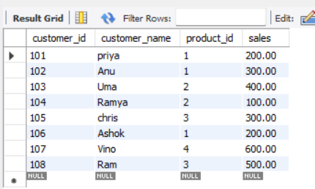
------Find the total sales revenue for each product----
9. select p.product_name,sum(s.sales) as total_sales_revenue from product p join sales s on p.product_id=s.product_id group by p.product_name;
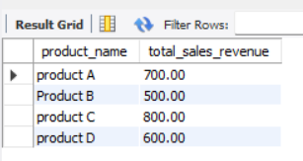

Project 4: Employee Performance with Subqueries

Objective: Find all employees whose performance score is above the company-wide average
1. create database mini40_db;
2.use mini40_db;
3. create table employee(emp_id int primary key,emp_name varchar(50),department_name varchar(50),performance_score decimal(10,2));
4. insert into employee values(101,'priya','HR',3.5),(102,'Ram','HR',4),(103,'Ashok','IT',3),(104,'vino','finance',4),(105,'Uma','IT',4.5),(106,'krish','Finance',5);
5.select * from employee;
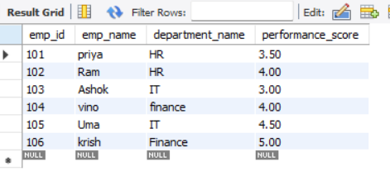
------calculate the average performance score,where clause to filter employees----
6. select * from employee where performance_score>(select avg(performance_score)from employee);
